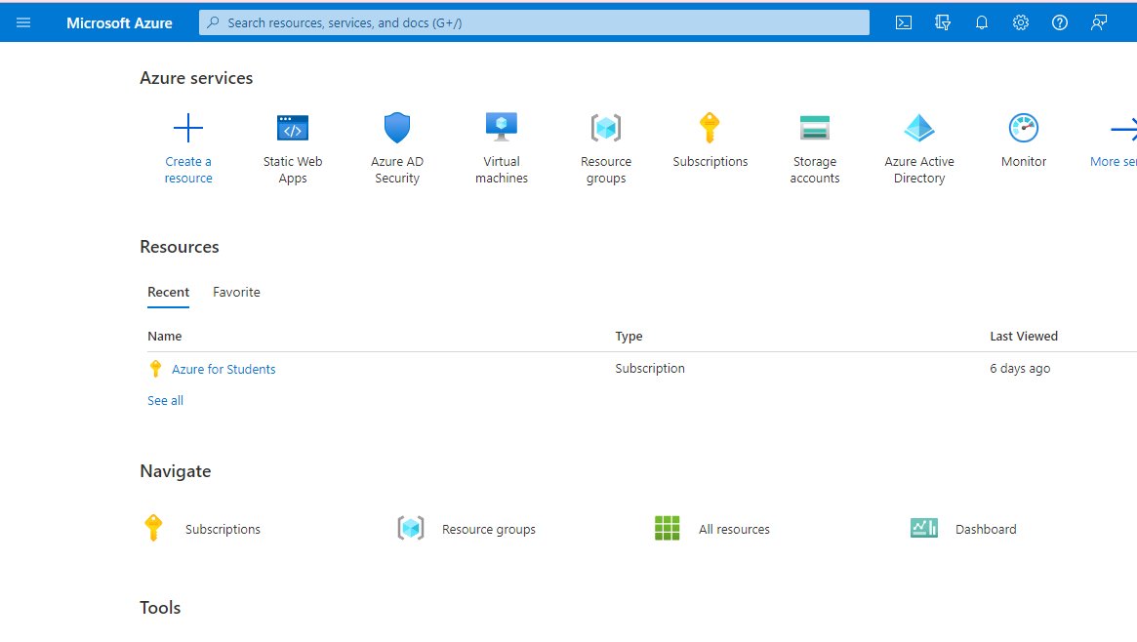

1.go to azure portal and search static web apps.

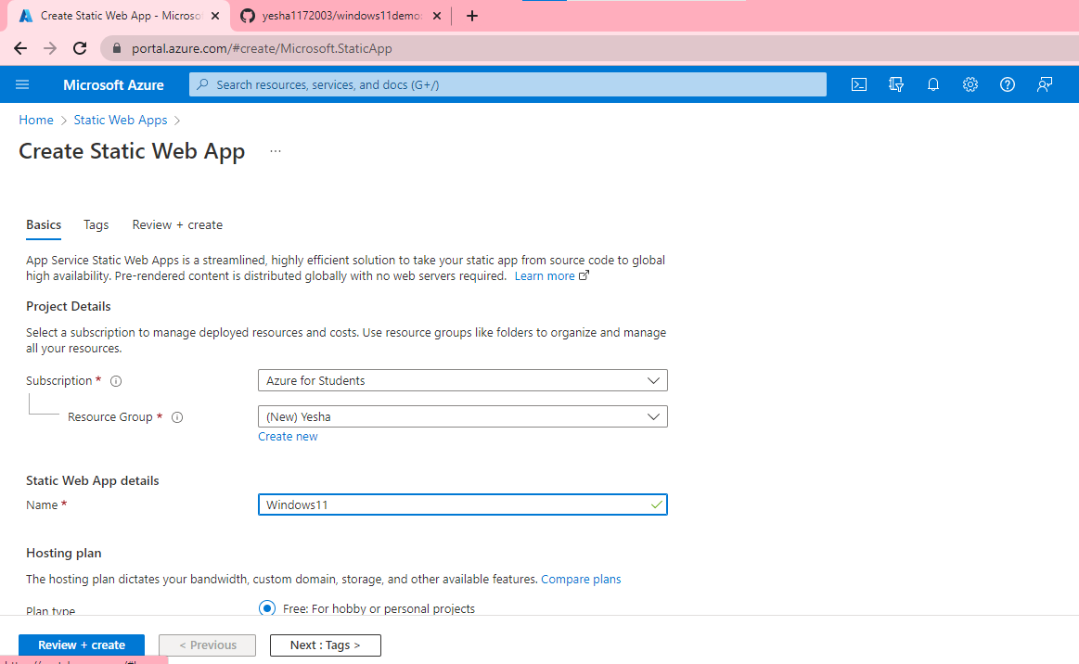

2.start creating webapps and create resource group.

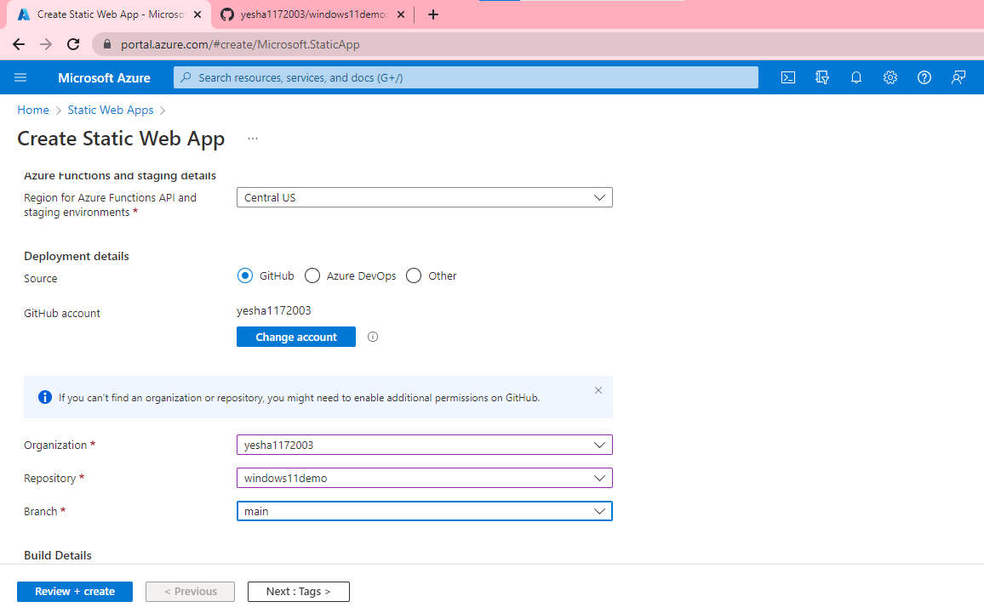

3.choose location and connect with your GitHub account and choose organization and repository and branch.

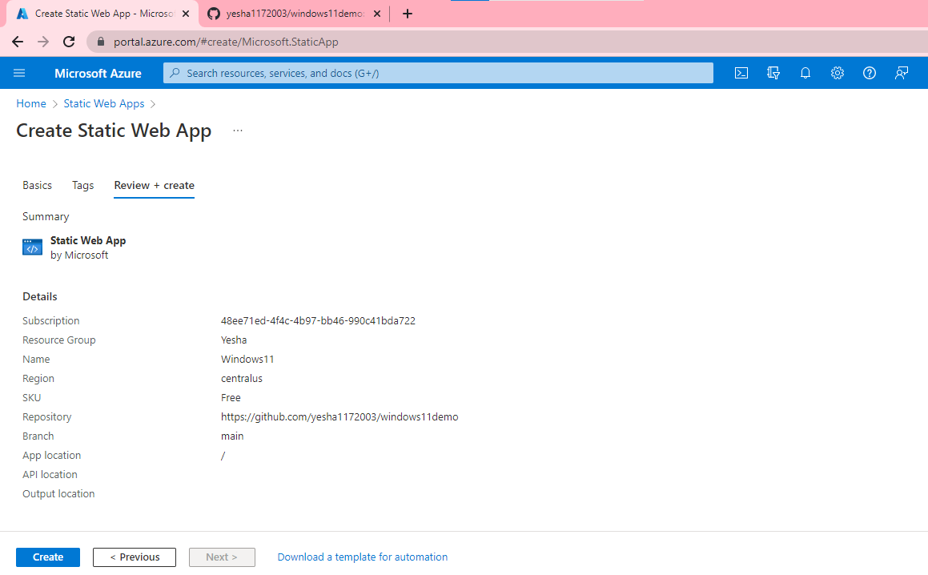

4.click review and create and then click create option.

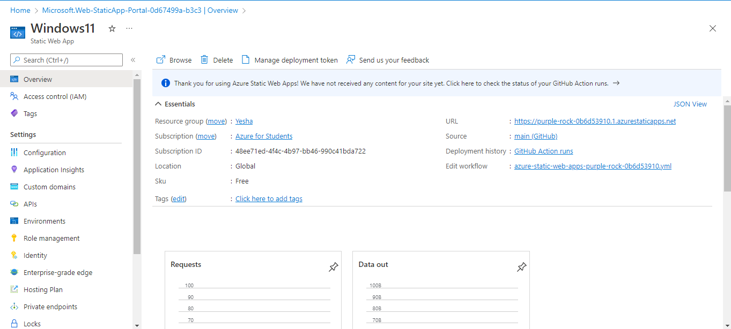

5.now you can see web app is hosted.

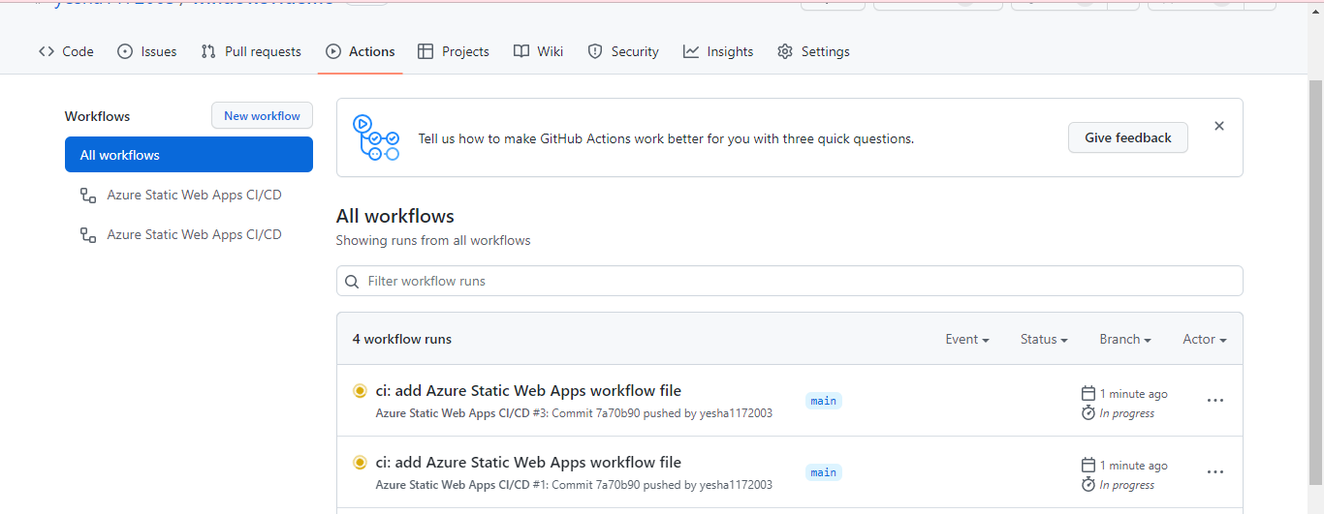

6. in GitHub action option start creating web apps workflow file.

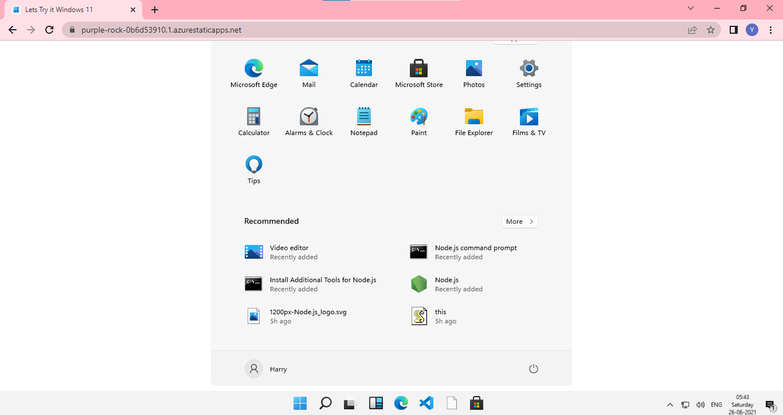

7.now you can see website is hosted.

Project link:- https://purple-rock-0b6d53910.1.azurestaticapps.net/